LOAN RATES AND FEES

BELOW IS GENERAL INFORMATION REGARDING ALL RATES AND FEES THAT WILL ASSIST YOU IN MAKING YOUR LOAN DECISION. IF YOU HAVE ANY QUESTIONS, OR WOULD LIKE MORE
INFORMATION, PLEASE ASK. MAKE CERTAIN THE QUESTIONS THAT YOU ASK ARE ANSWERED. MAKE CERTAIN YOU UNDERSTAND THE TERMS AND COSTS OF YOUR LOAN.
ANNUAL PERCENTAGE RATE (APR)
The cost of your credit as a yearly rate. APR is a combination of the interest rate plus the fees charged on your loan. APR is higher than the interest rate because it includes both fees and interest as ﬁnance charges.
Your actual terms and the Annual Percentage Rate (APR) will be determined at the time your application is submitted and will be based upon your application and credit information. Not all applicants will qualify for the lowest rate.
The calculation of APR is mandated pursuant to Federal Law (12 CFR Part 1026 - Truth in Lending Act (“TIL-APR”)). It is intended to provide a single value for a consumer to compare the cost of credit between one lender and another. Under New Mexico law, an additional type of annual percentage rate (“NM-APR”) must be disclosed, which may include additional charges that are not included in the TIL-APR. The NM-APR for a loan in an amount of more than $500 and up to $10,000 made pursuant to the Small Loan Act of 1955 or the Bank Installment Loan Act of 1959 cannot exceed thirty-six percent. The NM-APR for a loan in an amount of $500 or less made pursuant
to the Small Loan Act of 1955 or the Bank Installment Loan Act of 1959 cannot exceed thirty-six percent plus a fee that shall not exceed ﬁve percent of the total principal of the loan and shall not be imposed on any borrower more than once per twelve-month period.
FEES - A list of all fees that you may be charged.

Periodic Interest | 0.00% - 36.00%
Loan Processing Fee | 10% of the Amount Financed, not to exceed $200.00
Certificate of Title Fee | As required by New Mexico Motor Vehicle Division
Recording/Release Fee | As required by New Mexico Motor Vehicle Division
Legal Fee | Actual Cost Incurred
Repossession Fee | Actual Cost Incurred
Late Payment Fee | 5% of the unpaid payment, not to exceed $10.00

TO REPORT A PROBLEM OR COMPLAINT WITH THIS LENDER, YOU MAY WRITE OR CALL:  Customer Relations Manager Mariner Finance, LLC  8110 Corporate Drive  Nottingham, MD 21236  Phone: 844-338-2080  Email: customerrelations@marinerfinance.com | New Mexico Only: This lender is licensed and regulated by the New Mexico Regulation and Licensing Department, Financial Institutions Division,  P.O. Box 25101, 2550 Cerrillos Road, Santa Fe, New Mexico 87504.  To report any unresolved problems or complaints,  contact the Division by telephone number  (505) 476-4885 or visit the website:  www.rld.nm.gov/financial-institutions/.
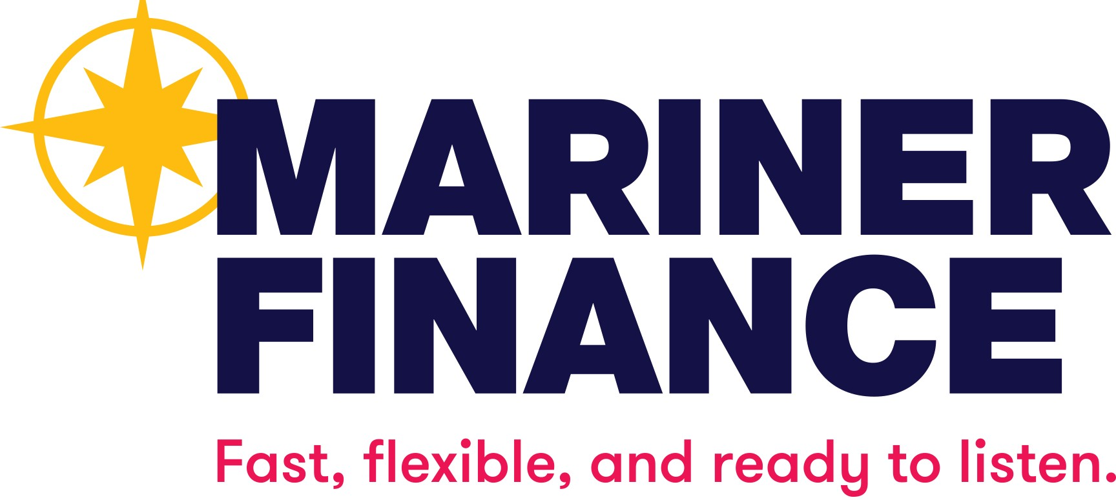
R7.2026

