**About Mariner Finance**

Since 1927, the Mariner Finance family of companies have provided individually tailored and convenient lending options to its customers with the goal of pairing

them with a personal loan that meets their immediate needs.

At the core of Mariner Finance is the principle that superior customer service will build lasting relationships. Our experienced team members take pride in finding options that are beneficial to each customer’s specific needs and are ready to assist you.

Superior customer service is the reason for our continued success and why we are recognized by our customers as the

community’s consumer finance company of

choice.

**Have questions? We’re here to help!**

Call 1-800-516-0139 to reach your local branch or visit us at [www.marinerfinance.com.](http://www.marinerfinance.com/)

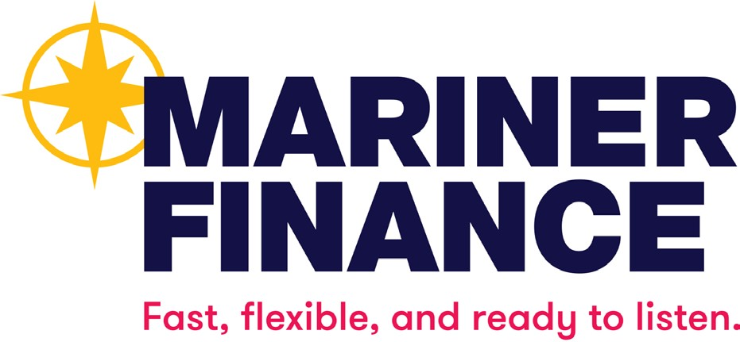

New Mexico Only: This lender is licensed and regulated by the New Mexico Regulation and Licensing Department, Financial Institutions Division,

P.O. Box 25101, 2550 Cerrillos Road, Santa Fe, New Mexico 87504.

To report any unresolved problems or complaints, contact the division by telephone at (505) 476-4885 or visit the

website:

[www.rld.nm.gov/financial-institutions/.](http://www.rld.nm.gov/financial-institutions/)

IMPORTANT CONSUMER INFORMATION

**Mariner Finance takes a customer first approach to lending by providing loan solutions to meet each customer’s specific needs.**

**Our loan process provides a fast approval process in an easy to understand and transparent manner.**

**This brochure contains some common terms and definitions, which are intended to help you better understand your credit transaction. Credit costs money, so it is important that you fully**

**understand the terms of your credit transaction. If you come across terms you do not understand,**

**look up the terms, or ask our personnel to explain the terms to you. Ask questions. Make**

**certain the questions that you ask are answered. Make certain you understand the terms and costs of your loan.**

**R3.2023**

**Common Terms and Definitions**

# Annual Percentage Rate (APR).

The cost of your credit as a yearly rate. APR is a combination of the interest rate plus the fees charged on your loan. APR is higher than the interest rate because it includes both fees and interest as finance charges.

The calculation of APR is mandated pursuant to Federal Law (12 CFR Part 1026 – Truth in Lending Act (“TIL-APR”)). It is intended to provide a single value for a consumer to compare the cost of credit between one lender and another. Under New Mexico law, an additional type of annual percentage rate (“NM-APR”) must be disclosed, which may include additional charges that are not included in the TIL-

APR. The NM-APR for a loan in an amount of more than $500 and up to $10,000 made pursuant to the Small Loan Act of 1955

or the Bank Installment Loan Act of 1959 cannot exceed thirty-six percent. The NM- APR for a loan in an amount of $500 or less made pursuant to the Small Loan Act of 1955 or the Bank Installment Loan Act of

1959 cannot exceed thirty-six percent plus a fee that shall not exceed five percent of the total principal of the loan and shall not be imposed on any borrower more than once per twelve-month period.

# Balance.

The total amount of money owed to a lender.

# Collateral.

Security pledged by a borrower to protect the interests of the lender; in case of default, the lender may take ownership of the security, if any, pledged by the borrower.

# Contract.

A written binding document, describing terms of an agreement between two or more persons. (Keep all paperwork. Later, if there are any questions, you will have your agreement in writing.)

# Credit Bureau.

A private company that keeps a record of your credit history for distribution upon request by authorized parties. When you apply for credit, a lender may request a credit report to review when considering your application.

# Credit History.

A record containing information about you, including your payment history on previous debts.

# Credit Report.

A report of the credit history and other information about you that is kept by credit bureaus, which may include: your name, address, social security number, payment history (good and bad), current and previous debts, employers, income, etc. Accurate information on a credit report may not be legally removed. Incorrect information may be removed by disputing the information to the credit bureau involved.

# Default.

Failure to pay a debt as agreed to on a contract. When a loan is in default, the lender may demand full payment of the remaining debt.

# Equal Credit Opportunity Act (ECOA).

A federal regulation which requires lenders to promote the availability of credit to all creditworthy applicants without regard

to race, color, religion, national origin, sex, marital status, or age (provided the applicant has the capacity to contract); to whether all or part of the applicant’s income derives from a public assistance program; or to whether the applicant has in good faith exercised any right under the Consumer Credit Protection Act. The

regulation prohibits creditor practices that discriminate on the basis of any of these factors.

# Finance Charge.

The dollar amount the credit will cost you. Finance charges include interest, and may also include transaction fees and service fees.

# Interest.

The cost of borrowing money, generally a percentage of the amount owed.

# Principal.

The amount of money owed on a debt, on which interest is calculated.